Molloy College
Division of Education

Students: Jaclyn Scorce & David Robbins Professor: Dr. Sheenan
Course EDU 5090 Date: 4.30.19
Grade: 4 Topic: Geography Content Area: Social Studies

INSTRUCTIONAL OBJECTIVES (s)

After introducing a lesson on geography using Google Earth, students will evaluate the validity of reasoning to gather information in order to form an opinion on the given question “Was the industrial revolution fueled by Natural Resources or Grit”? Students will create their own Google Earth tour incorporating two out of the five themes of geography discussing how their location effects the way they live and will be evaluated on a teacher-created rubric and obtain a minim score of 3 out of 4.

NYS-CCLS / +NYS STANDARDS AND INDICATORS

NEW YORK STATE SOCIAL STUDIES STANDARDS

Key Idea: 4.6 Westward Movement and Industrialization:
New York State played an important role in the growth of the United States. During the 1800s, people traveled west looking for opportunities. Economic activities in New York State are varied and have changed over time, with improvements in transportation and technology. (Standards: 1, 3, 4; Themes: MOV, TCC, GEO, ECO, TECH)

Key Concept: 4.6E: Entrepreneurs and inventors associated with New York State have made important contributions to business and technology.

Indicator: This will be evident when students use the teacher created bus tour as their guide to answer the question “Was the industrial revolution fueled by Natural Resources or Grit”?

NATIONAL SOCIAL STUDIES STANDARDS AND THEMES

IV. Individual Development & Identity

Social studies programs should include experiences that provide for the study of individual development and identity so that a learner can:

e. Identify and describe ways family, groups, and community influence the individual’s daily life and personal choices

Indicator: This will be evident when students choose one of the five themes of geography and prove as to whether the industrial revolution was fueled by location or grit.

f. Explore factors that contribute to one’s personal identity such as interests, capabilities, and perceptions;

Indicator: This will be evident when the students create a Flipgrid video picking a theme of their choice and using this to support their belief and prove as to whether the industrial revolution was fueled by natural resources or grit.

NCSS C3 INQUIRY ARC
Dimension 3: Students will work toward conclusions about societal issues, trends, and events by collecting evidence and evaluating its usefulness in developing causal explanations.

Indicator: This will be evident when the students virtually interact with their classmates by responding to their post either in agreement or disagreement using supporting evidence gathered from the bus tour.

Dimension 4: Students will draw on knowledge and skills to work individually and collaboratively to conclude their investigations into societal issues, trends, and events and will present their information, portions, and findings.

Indicator: This will be evident when students work collaboratively to gather evidence in class based on what they learned about the five themes of geography, the bus tour as well as independently create their own Flipgrid posts to prove whether the industrial revolution was fueled by natural resources or grit.

Common Core ELA Standards

Text Types and Purposes

3. Write narratives to develop real or imagined experiences or events using the effective technique, well-chosen details, and well-structured event sequences.

Indicator: This will be evident when the students create flip grid discussions to explain whether they agree or disagree if the industrial revolution was fueled by natural resources or grit.

Production and Distribution of Writing

6. Use technology, including the internet, to produce and publish writing and to interact and collaborate with others.

Indicator: This will be evident when the students create flip grid discussions to explain whether they agree or disagree if the industrial revolution was fueled by natural resources or grit.

Comprehension and Collaboration
1. Prepare for and participate effectively in a range of conversations and collaborations with diverse partners, building on others’ ideas and expressing their own clearly and persuasively.
Indicator: This will be evident when the students respond to their fellow peers commenting on their flip grid discussions regarding their opinion of whether the industrial revolution was fueled by natural resources or grit.

INSTRUCTIONAL RESOURCES

- SMART Board
- Google Slides
- Flipgrid
- Google Earth
- Teacher created rubric (A)
- 5 Themes of Geography handout (B)
- Teacher created Google Earth tickets (C)

MOTIVATION

Students will receive a bus ticket when entering the room that will allow them to board the Google Earth Bus Tour. Without giving too much away and leaving students in suspense, the teacher will review the five themes of geography to assure they have the correct background prior to their virtual tour.

DEVELOPMENTAL PROCEDURES

- The teacher will introduce the lesson by greeting the students at the door and passing out the Google Earth Bus Tour Tickets [Teacher created Google Earth tickets (C)].
- The teacher will then transition to teaching the five themes of geography by discussing the different factors that have an effect on the way people live to ensure students have the proper amount of background knowledge before beginning the virtual tour. (How would living in the desert be different than living near the ocean? What types of businesses would a community have if they lived in a rural area? What industries would be successful and what industries would not? Why do you believe they were/were not successful? Would these factors have an effect on a population during a time period such as the Industrial Revolution?)
- The teacher will then inform the students that the only way to know the impact the five themes of geography had on the Industrial Revolution is to go there.
- The teacher will then take the students through the virtual bus tour which they will use to answer the given question “Was the industrial revolution fueled by Natural Resources or Grit”?
- The students will be taken on a virtual experience where they will need to gather evidence in support of their answer on the 5 Themes of Geography handout (B).
- The students will use their evidence to create their own Google Earth Tour in a teacher assigned group incorporating two out of the five themes of geography and discussing how their location effects the way they live and will be evaluated on a teacher-created rubric and obtain a minim score of 3 out of 4.
- The students will present their video to the class.

INSTRUCTIONAL STRATEGIES

Cooperative Learning - Engaging groups of students working together on a structured activity.

Indicator: This will be evident when students work in randomly selected groups to complete a worksheet on the five themes of geography, identifying key ideas/concepts.

Direct Instruction - Explicit presentation of information.

Indicator: This will be evident when the teacher is teaching students about the 5 themes of geography and grit.

Discussion - Engaging in meaningful discussions about the content.

Indicator: This will be evident when students are discussing the ways in which they believe the industrial revolution was fueled by natural resources or grit, both in class and through their Google Earth presentation.

ADAPTATIONS

- For the student who struggles to work in small groups, they will be encouraged to select his/her own group.
- For the student who struggles with writing, they will be given the option to write, type or record his/her responses.
- For the student who struggles to stay focused will be seated near the teacher in the front of the room and will be given silent signals when needed.

DIFFERENTIATION OF INSTRUCTION

Auditory Learners:
In order to adapt to the auditory learners, they will be able to listen to the teacher as well as listen to examples of the flip grid assignments. Auditory learners will also have additional examples of the flip grid assignment available for them to use for additional resources.

Visual Learners:
The visual learners will be able to visualize these historical events through revisiting the Google Earth tour. This exercise will activate students’ episodic memory.

Intrapersonal Learners:
Students will work independently during discussions about the five themes of geography. All students will have the opportunity to contribute to their groups Google Earth Tour in a way they feel most comfortable.

ASSESSMENT
Informal:
- Teacher will assess students homework from the night before
- Teacher will assess students understanding of historical thinking strategies through discussion
Formal:
- Teacher will assess how the students interact during group work
- Teacher will assess the responses to the flip grid assignment using a teacher created rubric scoring 3/4.

INDEPENDENT PRACTICE

Following the lesson on geography and learning about the five themes of geography, students will create their own Google Earth tour. The teacher will provide feedback based on each students submission.

FOLLOW-UP ACTIVITIES: DIRECT TEACHER INTERVENTION AND ACADEMIC ENRICHMENT

Direct Teacher Intervention
For the students who struggled during the lesson, the teacher will review the concepts of creating a FlipGrid and highlight the important information for the student. The teacher will then help the student write a rough draft of their FlipGrid piece through a Q & A brainstorming exercise.

Academic Enrichment
The students who excelled with ease throughout the lesson will be challenged in their reflection to create a History Mystery assignment and share it with the class.

References

E. (2017, February). New York State K-8 Social Studies Framework. Retrieved from
http://www.p12.nysed.gov/ciai/socst/documents/ss-framework-k-8a2.pdf

Five Themes of Geography Graphic Organizer. (n.d.). Retrieved from https://www.teacherspayteachers.com/Product/Five-Themes-of-Geography-Graphic-Organizer-915619

Google Earth. (n.d.). Retrieved from https://www.google.com/earth/

M. (2017, September 14). Molloy College Division of Education Lesson Plan Standards [Teacher Created Template for Lesson Planning Directionality]. Rockville Centre, NY, 11571.]

National Curriculum Standards for Social Studies. Retrieved from file:///C:/Users/Acer/Downloads/NCSS%20National%20Themes%20(3)%20(5).pdf

New York State Next Generation English Language Arts Learning Standards. (n.d.) Retrieved from http://www.nysed.gov/common/nysed/files/programs/curriculum-instruction/nys-next-generation-ela-standards.pdf

TEACHER CREATED RUBRIC (A)

Digital Storytelling: 5 Themes of Geography
- Teacher Name: Mr. Robbins
- Teacher Name: Ms. Scorce
Student Name: ________________________________________

CATEGORY | 4 | 3 | 2 | 1
Point of View - Awareness of Audience | Strong awareness of audience in the design. Students can clearly explain why they felt the vocabulary, audio and graphics chosen fit the target audience. | Some awareness of audience in the design. Students can partially explain why they felt the vocabulary, audio and graphics chosen fit the target audience. | Some awareness of audience in the design. Students find it difficult to explain how the vocabulary, audio and graphics chosen fit the target audience. | Limited awareness of the needs and interests of the target audience.
Voice - Consistency | Voice quality is clear and consistently audible throughout the presentation. | Voice quality is clear and consistently audible throughout the majority (85-95%) of the presentation. | Voice quality is clear and consistently audible through some (70-84%)of the presentation. | Voice quality needs more attention.
Duration of Presentation | Length of presentation was 4 minutes. | Length of presentation was 3 minutes. | Length of presentation was 2 minutes. | Presentation was less than 2 minutes long OR more than 4 minutes.
Point of View - Purpose | Establishes a purpose early on and maintains a clear focus throughout. | Establishes a purpose early on and maintains focus for most of the presentation. | There are a few lapses in focus, but the purpose is fairly clear. | It is difficult to figure out the purpose of the presentation.

FIVE THEMES OF GEOGRAPHY HANDOUT (B)
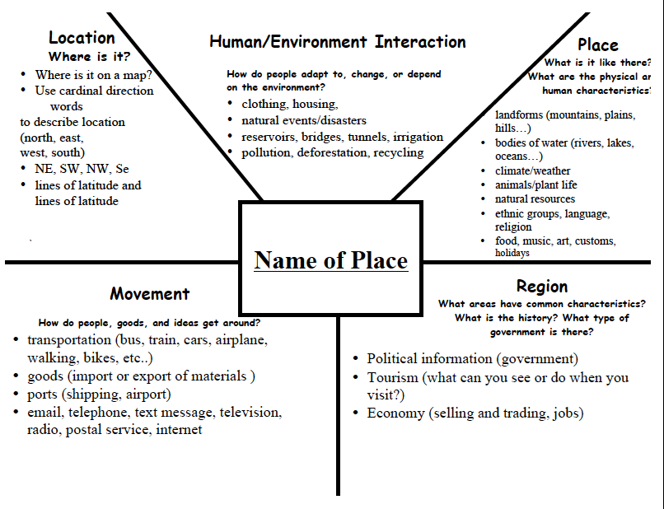
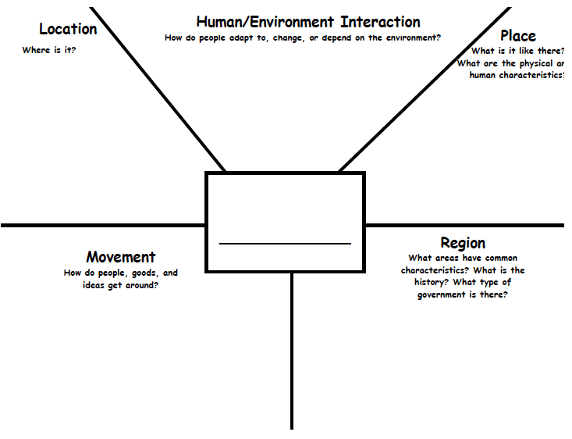

TEACHER CREATED BUS TOUR TICKETS (C)

