Molloy College
Division of Education

Student: Brianna Abatelli Professor: Kevin Sheehan
Course: EDU 351 01 Date: March 31, 2018
Grade: 5th Topic: Happiness Content Area: Social Studies

INSTRUCTIONAL OBJECTIVES (s) (Lesson Objective(s)*)
After listening to a book about why it is okay to make mistakes and viewing a PowerPoint about why optimism is the key to happiness, the students will write arguments to support claims using valid reasoning by writing about how they can flip four problems around to see the virtue they can gain from these problems. The students will provide three out of four valid arguments.

NYS-CCLS / +NYS STANDARDS AND INDICATORS
New York State Social Studies Standards
Key Idea:
5.4 GEOGRAPHY IN THE WESTERN HEMISPHERE: The diverse geography of the Western Hemisphere has influenced human culture and settlement in distinct ways. Human communities in the Western Hemisphere have modified the physical environment. (Standard: 3, Theme:GEO)
Key Concepts:
5.4c The physical environment influences human population distribution, land use, and other forms of economic activity.
Indicator: This will be evident when students make predictions about whether they think happiness is determined based on where you live at the end of the lesson, after learning about what the key to happiness is. Students will be asked what aspects of the United States physical environment makes them happy. They will be asked if other countries have these environmental attributes, and if they do not, does this mean that they are not happy.

Key Idea:
5.5 COMPARATIVE CULTURES: The countries of the Western Hemisphere are diverse and the cultures of these countries are rich and varied. Due to their proximity to each other, the countries of the Western Hemisphere share some of the same concerns and issues. (Standards: 1, 2; Themes: ID, MOV, SOC)
Key Concepts:
5.5a The countries of the Western Hemisphere have varied characteristics and contributions that distinguish them from other countries.
5.5b. Countries in the Western Hemisphere face a variety of concerns and issues specific to the region.
Indicator: This will be evident when students make predictions about whether they think happiness is determined based on where you live at the end of the lesson, after learning about what the key to happiness is. Students will be asked what characteristics of the United States makes them happy. They will be asked if other countries have these characteristics, and if they do not, does this mean that they are not happy.

National Social Studies Standards and Themes

I. Culture
Social studies programs should include experiences that provide for the study of culture and cultural identity.
Indicator: This will be evident when students make predictions about whether they think happiness is determined based on where you live at the end of the lesson, after learning about what the key to happiness is. This question makes students tap into their prior knowledge about their culture and other countries' cultures to provide evidence to support their claim.
IV. Individual Development & Identity
Social studies programs should include experiences that provide for the study of individual development and identity.
Indicator: This will be evident when students learn that it is okay to make mistakes and that optimism is the key to happiness. This will help students to learn to grow individually so that they can live happier lives.

NCSS C3 Inquiry Arc

Dimension 2: Students will analyze societal issues, trends, and events by applying concepts and tools from civics, economics, geography, and history. Look with lens and skills of the discipline.

Dimension 3: Students will work toward conclusions about societal issues, trends, and events by collecting evidence and evaluating its usefulness in developing casual explanations.
Indicator: This will be evident when students analyze the societal issue of what determines one's happiness. After learning about how optimism is the key to happiness, students will work towards conclusions about whether they think where you live determines your happiness.

Social Studies Practices: Habits Of Mind

Gathering, Interpreting and Using Evidence
6. Recognize arguments on specific social studies topics and identify evidence supporting the argument.
Indicator: This will be evident when students recognize the argument that the ability to be optimistic determines one's happiness. Throughout the lesson, students will identify evidence that supports this claim.

Civic Participation
1. Demonstrate respect for the rights of others in discussion and classroom debates, regardless of whether one agrees with the other viewpoint. Consider alternate views in discussion, with teacher support.
Indicator: This will be evident when students discuss with one another what determines one's happiness and if where you live determines your happiness.

Common Core ELA Standards

College and Career Readiness Anchor Standards for Writing
Texts Types and Purposes
Write arguments to support claims in an analysis of substantive topics or texts, using valid reasoning and relevant and sufficient evidence.
Indicator: This will be evident when students write about how they can flip four problems around to see the virtue they can gain from these problems. Students will have to provide a valid argument by using relevant and sufficient evidence regarding why these problems can be turned into something positive.

English Language Arts Standards
NYS CCLS: SL.5.1
Domain: Speaking and Listening; Comprehension and Collaboration
Standard: Engage effectively in a range of collaborative discussions (one-on-one, in groups, and teacher-led) with diverse partners on grade 5 topics and texts, building on others’ ideas and expressing their own clearly.
Indicator: This will be evident when the students discuss the book, It's Okay to Make Mistakes, with each other by completing the "Book, Head and Heart" activity. Students will also discuss various questions the teacher presents to them about the book. Students will build upon each other's answers and perspectives until they come to a conclusion.

INSTRUCTIONAL RESOURCES
- Google Slides
- SmartBoard
- It's Okay to Make Mistakes by Todd Parr
- "It's Okay to Make Mistakes!" Worksheet
- "Book, Head & Heart" Worksheet
- "Book, Head & Heart" Poster Board
- Three different colored post-its notes
- "Optimism is the Key to Happiness" Worksheet
- "Happiness Is & Happiness Is Not" Cards
- "Happiness Is & Happiness Is Not" Chart
- "The Flipside of Problems" Worksheet
- "Flipgrid With a Parent" Worksheet
- Flipgrid
- Laptops

MOTIVATION (Engaging the learner(s)*)
The students will listen to two short personal anecdotes told by the teacher. The teacher will discuss the difficult transition she went through in sixth grade and the much easier transition she went through in college. After hearing the events of each transition, the students will have to discover why it was easier for her to make the transition to college than to sixth grade. (What factor made these two events in my life very different from one another?)

DEVELOPMENTAL PROCEDURES
(including Key Questions)
- The students will read the book, It's Okay to Make Mistakes by Todd Parr, as a class. After reading the book, the students will complete a "Book, Head and Heart" activity. The students will be split up into three groups based on the color post-it note they are given. The students in the "Book" group will each write one aspect about what the book is about on their post-it notes. The students in the "Head" group will each write one why this book changed, challenged, or confirmed their thinking on their post-it notes. The students in the "Heart" group will each write one why this book will help them to be better or what this book taught them about themselves on their post-it notes. Students will then stick their post-it notes on the correct poster board in the front of the classroom. Then, as a class the students will discuss with each other and the teacher, what this book was about and what this book taught them. The students will have a worksheet with questions on it to help guide this discussion. (What are two examples, from the book, of mistakes we can make and why it is okay to make those mistakes? What is one of your examples of mistakes one can make and why it is okay to make that mistake? What is one mistake you have made? How have you learned from that mistake? How should we react to the events, even the bad events, that happen in our lives? What is the definition of optimism in your own words. Can you give an example? How does this book relate to the idea of optimism? Why do you think optimism is the key to happiness?)

- The students will then view a PowerPoint about what happiness is and why optimism is the key to happiness. The PowerPoint will consist of a discussion about what happiness is and a diagram that explains what determines our happiness. The teacher will focus on the portion of the diagram that says that only 10% of our happiness is determined by our circumstances, because we get use to our circumstances over time. Students will then be given cards that describe what happiness is and what happiness is not. The students will have to sort the cards and determine which cards describe what happiness is and which cards describe what happiness is not. The students will then place the cards in the correct column on the board. The students will then discuss what all cards in the "happiness is" column have in common, and what all the cards in the "happiness is not" column have in common. This will lead into a discussion about why optimism is the key to happiness. (What does happiness mean to you? What is your definition of happiness? Use an example from your own life to defend your definition of happiness. What do you notice about all the cards that describe what happiness is? What do you notice about all the cards that describe what happiness is not? Why is optimism the key to happiness? What strategies can you use to live a happier life? Which strategy is most efficient for you? Explain why or why not.)

- The students will then complete an exit ticket. Students will have to write four valid arguments about how they can flip four problems around to see the virtue they can gain from these problems.

- The students will review with the teacher what they learned about today regarding happiness. The student will also be asked to think about the question, "Does where you live determine your happiness?" This question will frame the students' thinking for the upcoming lessons within the unit. Students will begin to make predictions about whether they think happiness is determined based on where you live after learning about what the key to happiness is. (Can someone recap what we learned about today? Why is happiness such an important topic that should be talked about in the world we live in today? What aspects of the United States physical environment make you happy? Does this mean that countries that do not have these environmental attributes are not happy? Explain. What characteristics of the United States makes you happy? Does this mean that countries that do not have these characteristics are not happy? Explain.)

INSTRUCTIONAL STRATEGIES (Learning Strategies*)
Direct Instruction
Indicator: This will be evident when students are viewing a PowerPoint about what happiness is and why optimism is the key to happiness. The teacher will explain to the students the research that has been done regarding what happiness is and how we can live happy lives.
Modeling
Indicator: This will be evident when students participate in the "Book, Head, and Heart" activity and the "Happiness Is" and "Happiness Is Not" card activity. At the beginning of each activity the teacher will not only give instructions on what the students should be doing, but will also model how to effectively participate in these activities in a way that will expand their way of thinking.
Indirect Instruction
Indicator: This will be evident when the students discuss the book, It's Okay to Make Mistakes. Even though the teacher will be asking questions that guides the students' thinking, ultimately the students are the ones gathering the information in order to make valid conclusions about happiness. Furthermore, after learning about the research that has been done about happiness, the students will have to come to their own conclusions about what happiness is and what happiness is not by sorting out the cards they are given into the right columns. After completing this activity, the students will be able to discover and understand why optimism is the key to happiness is.

ADAPTATIONS (Exceptionality*)
For the student in my class with ADHD, I will use refocusing and redirection strategies to help keep this student on task. When this student starts getting distracted, I will place a nonverbal cue card on his desk that has a picture of a student working to let him know that he is getting distracted and needs to redirect his focus on the activity. He will also have a checklist next to him that he can refer to in order to make sure he is staying on task.

DIFFERENTIATION OF INSTRUCTION
Visual Learners
The PowerPoint and the worksheets the students use in class will include pictures so that these students can visualize what happiness is and why optimism is the key to happiness. These visuals will also be provided on the "happiness is" and "happiness is not" cards they receive in class.
Auditory Learners
Throughout the lesson, the students will be discussing with each other and the teacher what happiness is and why optimism is the key to happiness. Whether it is the teacher explaining the research that has been done regarding happiness, or the students explaining their arguments about happiness, the auditory learners will get to hear many different perspectives in order to develop their understanding of optimism and happiness. Furthermore, the auditory learners will be given a worksheet that has all the notes from the PowerPoint at the end of the lesson so that they can focusing on listening to the teacher rather than taking notes.
Kinesthetic Learners
After listening to the book, It's Okay to Make Mistakes, the students will have to complete a "Book, Head and Heart" activity, where they must place their post-it note responses on the correct poster board in front of the classroom. This will allow these students to get out of their seats and move around as they put their post-it notes in front of the classroom. Furthermore, while viewing the PowerPoint, the students will each receive a card that describes what "happiness is" or what "happiness is not". After deciding which card they have, they will have to place that card in the correct column in the front of the classroom. This will also allow these students to once again get out of their seats and move around.
Tactile Learners
While discussing the book as a class, students will be given a worksheet with the questions they will be discussing and a space to write their answers. This will allow these students to write their responses and their classmate responses, so that their hands are moving as they are listening, allowing them to better comprehend the lesson. Also, while viewing the PowerPoint, the tactile learners will be given a worksheet that requires them to fill out parts of the notes that is in the PowerPoint.

ASSESSMENT (artifacts* and assessment [formal & informal]*)
- Students will have to complete an exit ticket to review what they had learned about during this lesson about happiness and optimism. Students will have to write valid arguments about how they can flip four problems around to see the virtue they can gain from these problems. The students will have to provide at least three out of four valid arguments.
- The teacher will informally assess the students by taking notes about if each of the students are understanding the material, as the students are completing their classwork and participating in class discussions.

INDEPENDENT PRACTICE
For homework, the students will have to ask one of their parents about a time he or she overcame a difficult circumstance he or she was in with the help of optimism. The students will then have to make a flipgrid to tell their parent's story, and discuss what they learned about happiness and optimism from listening to their parent's story.

FOLLOW-UP ACTIVITIES: DIRECT TEACHER INTERVENTION AND ACADEMIC ENRICHMENT
Direct Teacher Intervention
The teacher will gather all the students who were unable to make at least three out of four valid arguments on the exit ticket during the do now. These students and the teacher will play a game called, "The Glad Game". The teacher will begin by presenting the students with a negative event. The students will then have to work together to come up with as many reasons as they can for why this negative event can actually be something positive. Then, the students will have to opportunity to present the group with a negative event, and the group will have to come up with reasons for why this can be turned into something positive. This activity will help the students to better understand the idea of optimism because they will have each other and the teacher to bounce ideas off of, and they will be able to present their own negative events that they are able to relate to.
Academic Enrichment
The students who were able to make at least three out of four valid arguments on the exit ticket, will work together to make an "Optimism Wall". These students will be given little squares pieces of construction paper, where the students will write about optimism. Students can write examples of what it means to be optimistic, strategies you can use to help you be optimistic, quotes about optimism, etc. The students will glue their squares of construction paper onto a poster board that will be hung up in the classroom to remind the students to be optimistic.

REFERENCES
Blow, M. (2017, April 13). Disrupting Thinking:Inspiring Deeper Reader Engagement.
Retrieved April 04, 2018, from https://www.scholastic.com/teachers/blog-posts/mary-b
low/2017/Book-Head-Heart-BHH-Reading-Helping-Students-to-Engage-With-the-Text/
M. (2017, April 13). How to be Happy - The Science of Happiness and Feeling Positive in Life.
Retrieved April 04, 2018, from https://www.youtube.com/watch?v=hsPpaHbvfQs
Parr, T. (2014). It's Okay to Make Mistakes. New York City, NY: Little, Brown Books for
Young Readers.

Name: ________________________ Date: __________________
Book, Head & Heart
Book- What's this about? Who's telling the story? What does the author want me to know?

Head- What surprised me? What does the author think I already know? What changed, challenged, or confirmed my thinking?
Heart- What did I learn about me? How will this help me to be better?
Name: ________________________ Date: __________________
It's Okay to Make Mistakes!
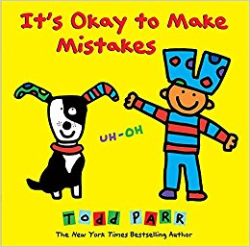
- What are three examples of mistakes we can make and why it is okay we made those mistakes? Use two examples from the book and one of your own.
  - ___________________________________________________________________________________________________________________________________
  - ___________________________________________________________________________________________________________________________________
  - ___________________________________________________________________________________________________________________________________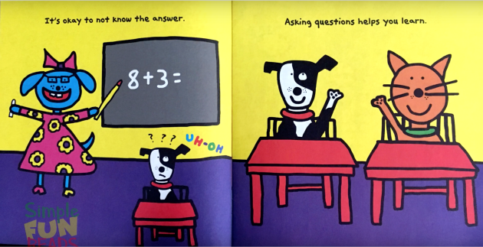
- What is one mistake that you have made? How have you learned from that mistake?
____________________________________________________________________________________________________________________________________
- According to this book, how should we react to the events that happen in our lives?
______________________________________________________________________________________________________________________________________________________________________________________________________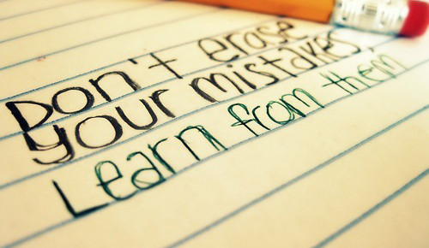

- How does this book relate to the idea of optimism?
______________________________________________________________________________________________________________________________________________________________________________________________________
- Why do you think optimism is the key to happiness?
__________________________________________________________________________________________________________________________________________________________________________________________________________________________________________

Name: ________________________ Date: __________________
Optimism is the Key to Happiness
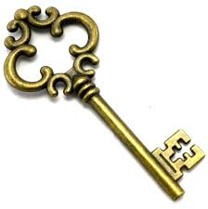
What is Happiness?
Happiness is a combination of . . .
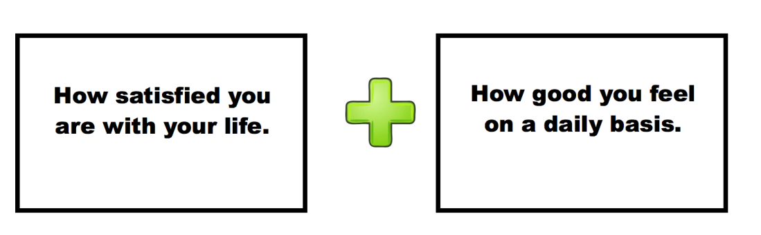
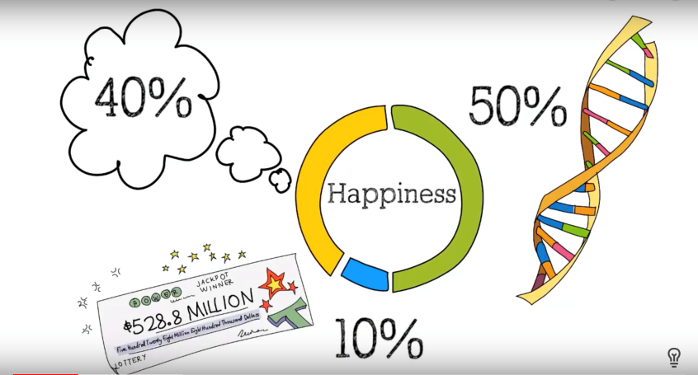
50% Genetics
40% Thoughts, Actions & Behaviors
10% Circumstances
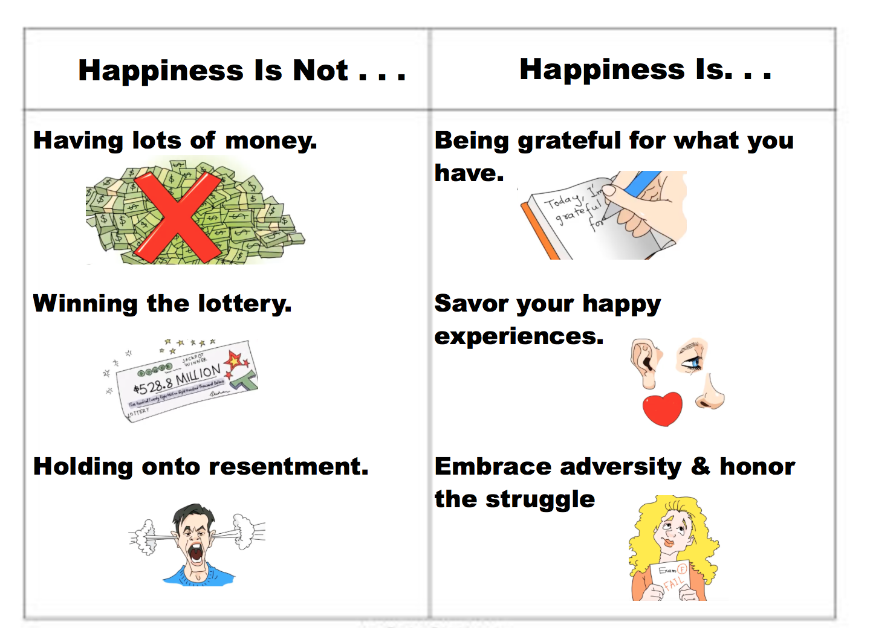
What is the Key to Happiness?
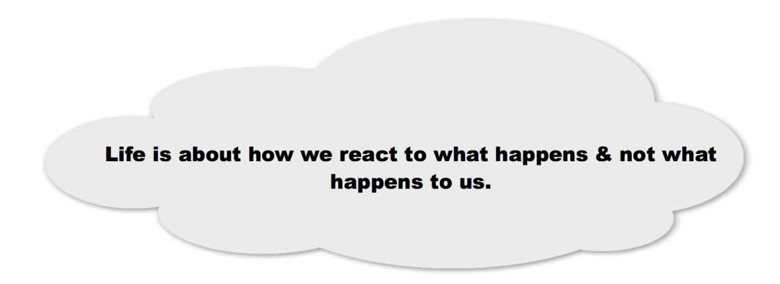
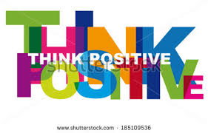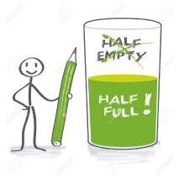

Name: ________________________ Date: __________________
Optimism is the Key to Happiness
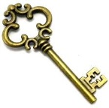
What is Happiness?
Happiness is a combination of . . .
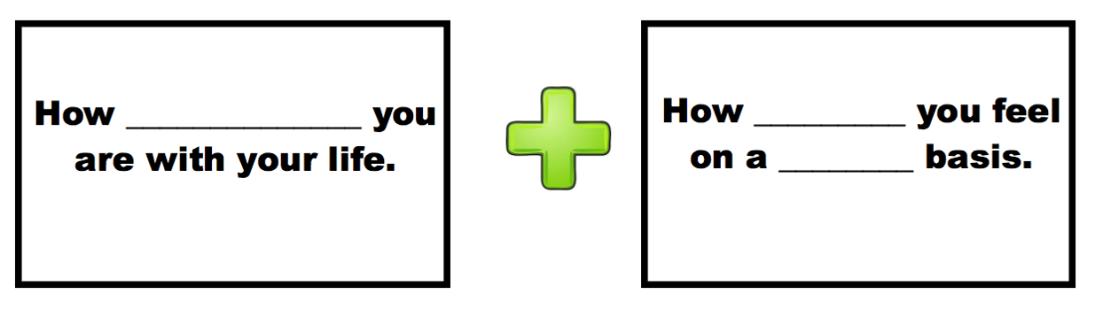
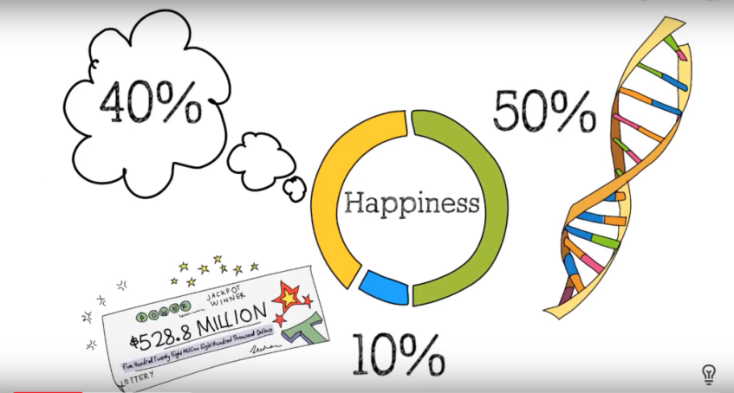
50% _______________
40% ______________________________
10% _______________________
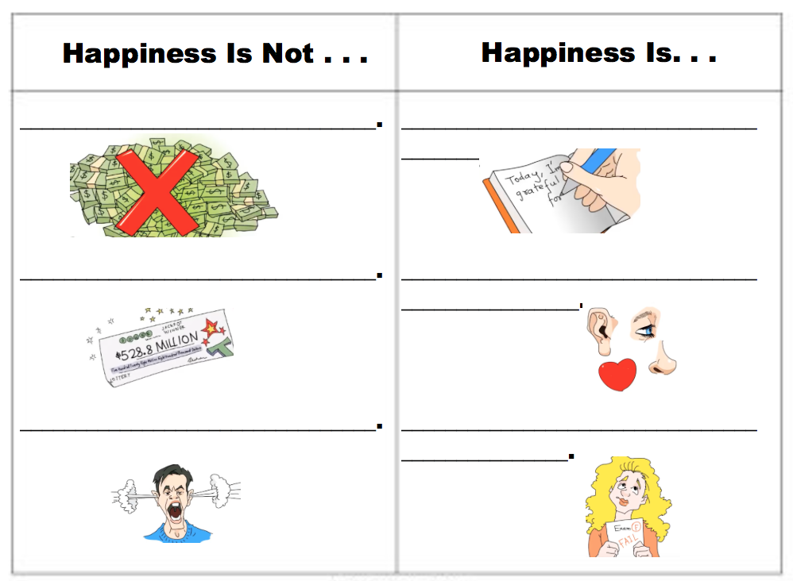
What is the Key to Happiness?
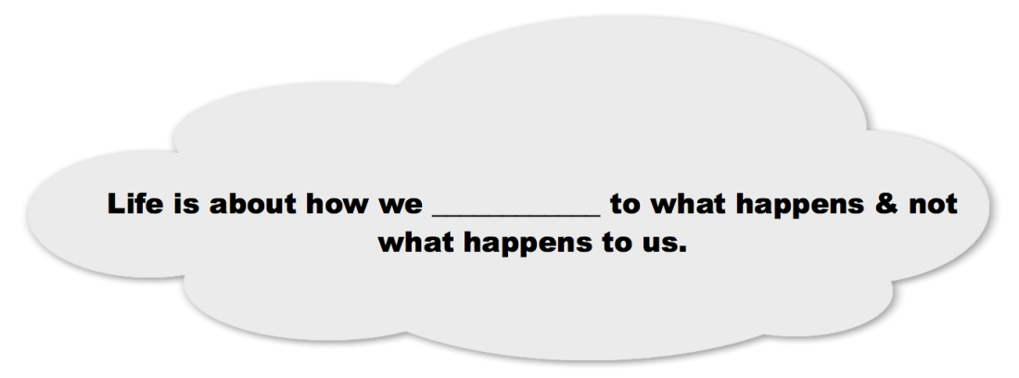
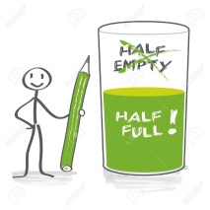

Name: ____________________________ Date: ______________________
The Flipside of Problems
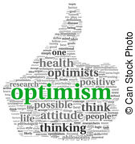
Directions: Read the following four problems. Figure out how you can flip these problems into something positive. What virtue can you gain from these problems?

- You failed a test because you did not have enough time to study.
_________________________________________________________________________________________________________________________________________________________________________________________________________________________________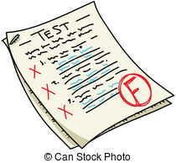
- You got into a fight with your friend because you and your friend could not see eye-to-eye.
_________________________________________________________________________________________________________________________________________________________________________________________________________________________________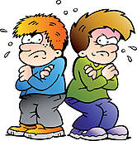
- You got detention because you kept forgetting to do your homework.
_________________________________________________________________________________________________________________________________________________________________________________________________________________________________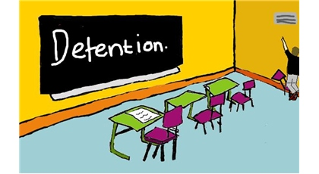

- You got in trouble with your parents because you refused to clean your room.
__________________________________________________________________________________________________________________________________________________________________________________________________________________________________________

Name: ____________________________ Date: _____________________
Flipgrid With a Parent
Directions: Ask your parent about a time he or she overcame a difficult circumstance he or she was in with the help of optimism. Make a flipgrid to tell your parent's story. Be sure to include what you learned about happiness and optimism from listening to your parent's story.

