Molloy College
Division of Education
Student Anna Bassolino, Kathleen Jensen, and Colin Kotarski Professor Sheehan
Course EDU 3150 Date 3/24/20
Grade: 5th Topic: Effects of Social Media Content Area Social Studies
STANDARDS AND INDICATORS

New York State Social Studies Standards
5.5 COMPARATIVE CULTURES: The countries of the Western Hemisphere are diverse and the cultures of these countries are rich and varied. Due to their proximity to each other, the countries of the Western Hemisphere share some of the same concerns and issues.
Indicator: This will be evident when students are empowered with the tools to accurately evaluate credibility on primary sources from Mexican history
5.5a The countries of the Western Hemisphere have varied characteristics and contributions that distinguish them from other countries.
Indicator: This will be evident when students are empowered with the tools to accurately evaluate credibility on primary sources from Mexican history
ELA Standard: New York State Next Generation English Language Arts
Learning Standards, Speaking and Listening Standard
Comprehension and Collaboration

5SL1:
Engage effectively in a range of collaborative discussions with diverse partners; express ideas clearly and persuasively, and build on those of others.
Indicator: This will be evident when students contribute to the anchor chart, correctly identifying characteristics of the characters in the skit before and after the class discussion.
ELA Standard: New York State Next Generation English Language Arts Learning Standard
Speaking and Listening Standard
Comprehension and Collaboration

5SL1c:
Pose and respond to specific questions by making comments that contribute to the discussion and elaborate on the remarks of others.
Indicator: This will be evident when students participate in the class discussion about how they feel and can relate to the other characters.
ELA Standard: New York State Next Generation English Language Arts Learning Standard
Speaking and Listening Standard
Comprehension and Collaboration

5SL3:
Identify and evaluate the reasons and evidence a speaker provides to support particular points.
Indicator: This will be evident when students ask characters in the skit questions to dive deeper into why they act the way they do.
NCSS Inquiry Standard
Dimension 1 of the arc features the developing of questions and the planning of investigations. With a robust question in mind, teachers and students determine the kind of content (Dimension 2) they need to create a plan to address their questions.

Indicator: This will be evident when the students ask the teachers and characters questions about thoughts, actions, and experiences with bullying.
Social Studies Habits of Mind
6. Civic Participation
Indicator: This will be evident when students complete their Quick write Quick Draw Exit ticket about a time they have stood up to bullying, or how they would do something different in a past encounter with a bully.
INSTRUCTIONAL OBJECTIVE(S)
After watching the skit “Haybale Harper,” about a girl from Kansas, students will participate in a class discussion about bullying and the effects of social media on personal and school environments while effectively connecting the scenario to their own life, identifying two characteristics of the characters on the “Body Charts” and completing the Quick Draw/Quick Write Assessment receiving no less than four out of five on a teacher-created checklist.
DEVELOPMENTAL PROCEDURES
- MOTIVATION - Students will participate in the "Stand up, Sit down" activity. (If any of the statements apply to you, please follow the directions by standing up or sitting down. If it applies to you and you are already standing or sitting, please remain standing or sitting.)
- Students will receive post-it notes to remember and write down any questions or comments that they have when their teachers are performing the skit. (When you receive the post-it note, please write your name on it. During the skit, if you have any comments or questions, feel free to write them down, and we can address any questions after the skit is over.)
- Students will watch a skit on the effects of social media bullying. (Please be respectful during the skit. Remember that if you have any questions or comments, you can write them down on the post-it note we gave you. If you feel uncomfortable at any time during the skit, please talk to an adult or take a walk outside the classroom.)
- Students will make judgments about the characters on anchor charts. (Behind us are big pieces of chart paper labeled with the character's names. When we call your table group up, you can make judgments about the character's "outside appearance" and who they are inside. For example, you might want to write on Kelly's outside that she's very mean and shallow. But do you know anything about who she is? Maybe she is struggling with her issues too? Write what you think about the characters "outside" first and then their "inside.")
- Students will be given a five-minute break to process the skit and to relax. (Okay, friends, let's take a five-minute break. You can get up, stretch, and talk to some friends.)
- Students will actively participate in a class-wide discussion about the characters from the skit. (How did the skit make you feel? Can you relate to this skit? Has anyone ever seen something like this before? What character do you relate to the most? If you were a character in this, what would you do? If you could rewrite the skit, would you change it?)
- Students will complete the "Quick write/Quick Draw" exit ticket. (We are handing out a Quick Write/Quick Draw activity. We want you to write about the skit and then draw about it. Please write about how you felt about the skit and make a connection to your life.)
- To close the lesson, a student volunteer will participate in an activity about actions and consequences. (We need one volunteer to come up and help us with an activity.)
ASSESSMENT
Informal assessment
When students are participating in the discussion the teachers will examine their comprehension of the skit.
Formal assessment
Students will complete the Quick Draw/Quick Write assessment receiving no less than four out of five on a teacher-created checklist.
REFERENCES
DeShaw, T. (2019, March 30). Informal Assessments A to Z: A list of Ideas. Retrieved from https://theowlteacher.com/informal-assessments-list-ideas/.
K-2 Next Generation ELA Standards at a Glance [PDF]. (n.d.). NYS Education Department.
New York State Education Department. (2015). NYS Standards Retrieved from http://www.nysed.gov/curriculum-instruction/k-12-social-studies-framework

Skit
5 Characters
- Bully - Kelly
- Victim - Harper aka
- Bystander/friend of the victim - Dylan
- Mean student - Alex
- Classmate- Nick
Summary
Harper Wyatt is a 9-year-old girl that has recently moved from Kansas to New York City because of her mother's new job. She has acclimated to the new environment impressively well and fits in with all of her classmates. When Harper is stressed or upset, she turns to her private and secret Instagram account dedicated to farm life. She posts about her animals, how to care for them, what it's like being responsible on the farm, and her creative outfits. Harper keeps this account a secret because she feels like the students in her class could never understand why she would love something they don't understand. But one day, her classmate Alex finds this Instagram and tells the meanest girl in class Kelly about it. Before she knows it, everyone is looking at Harper funny and laughing when she lets the word "y'all" slip. She asks her friend Dylan if she did anything wrong, and he just brushes it off, claiming, "That's weird, I have no idea why they're laughing."So she just brushes it off
One Friday afternoon, she is hanging out in her favorite outfit, green overalls, and posts a picture on her private account. Before bed, Harper decides to scroll on TikTok and discovers that there is a #HayBale challenge going on between her classmates. They have all posted videos to country music, dressed in overalls, and acting like farm animals. She becomes excited that her new friends have shown an interest in things she likes and cannot wait to go to school on Monday.
day.
Walking up to a crowd of people in the cafeteria
Harper: Hey, guys! How was your weekend? What did everyone do?
Kelly: It was great. I hung out with Nick, went to the movies, and my mom just told me over the summer we were going to go to Paris, so I went shopping.
Nick: my weekend was good. I went skateboarding.
Dylan: I hung out with my dad. We went to my grandpa's house and moved a bunch of stuff.
Alex: I stayed low key, babysat my cousins.
Harper: Wow, that all sounds like fun.
Dylan: Harper, what did you do this weekend?
Harper: I played with my sister and Facetimed my Aunt and Uncle in Kansas.
(The kids around the table start smiling at each other, but Harper doesn't notice)
Kelly: So, Harper, what do you have for lunch?
Nick: I'm having Tommy Turkey for lunch.
(He chuckles)
Alex: I'm having whatever they give me in the cafeteria, I just hope it's edible.
Dylan: I'm having peanut butter and jelly sandwich.**
Harper: I have bologna, it's my favorite!
Kelly: I am choosing to not eat meat because of the harsh living conditions of farm animals everywhere
Alex: Yeah, Harper, I am actually shocked that you're okay with eating animals considering…
Harper: Considering what?
Dylan: Considering you used to live on a farm with animals that you took care of.
Kelly: You mean she used to live on a farm with animals she would raise to eat
Nick: Woah, that's weird to think about, isn't it?
Kelly: Harper, what do you think about this?
Harper: I'm sorry I just didn't know all of you knew about my farm… I mean, I never told anyone.
Alex: I found your Instagram
Harper begins to get upset/surprised
Harper: I mean, I don't treat my animals harshly, I love them, and there are a lot of benefits to raising livestock.
Kelly: I just think it's odd. Are you eating one of your pigs now? Nobody here in New York does that. Or has even had animals before
(Trying to defend her)
Dylan: That's not true. I have---
Kelly: I saw on TikTok that farmers from Kansas also like country music… Is that true?
(She said nastily)
Alex: And overalls
(She laughs)
Nick: Do you go cow tipping? That's probably hilarious. I saw it in a movie once I think. I don't remember the movie, but it looked pretty cool--
Kelly: Nick!
Nick: What?
Dylan: I really don't think there is anything wrong with how she dresses?
Kelly: Dylan, she doesn't like the same things as us… She doesn't even have a TikTok or Snapchat.
Dylan: Neither do I--
Kelly: Anyway, Harper. I am just still so "interested" in this farm lifestyle you love so much. Please tell me more about it.
Alex: (deviously) Yeah, tell us more.
(They chuckle)
--- SCENE---

Skit Character Breakdown
Harper (the main character)- Harper is a 9-year-old, Kansas raised girl who loved her life at home. She was a real farmer's daughter and loved everything about the ranch she lived on. She rode horses, milked cows, took care of her chickens, and took care of her little sister, Mary, who has Down Syndrome. Harper is very protective of her sister and did not mind giving up her life in Kansas so that Mary could go to the best school, and her mother could work at a different law firm that could pay for Mary's medical expenses and schooling.
Kelly (the bully)- Kelly is a 10-year-old girl who feels like an inconvenience. Her parents got divorced when she was younger, and both of them travel a lot for work. She spends most of her time with her Au Pair, who is not very nice to her, and she has no siblings or animals at home to keep her company. Her friends at school tell her what she wants to hear, and she feels like nobody actually cares about her. She has struggled with depression at a young age, and every time she looks for help, she is told, it is all made up in her mind. Nobody at school knows what happens at her house, and she does not want anyone to find out.
Alex (neutral)- Alex is a 10-year-old girl that lives in a house with her grandmother, mother, father, four siblings, aunt, uncle, and three cousins. Because her family is very proud of their Latino heritage, their house is always loud, whether it be from music, dancing, screaming, or just the fact that there are 13 people in a three-bedroom house. They are very close to each other but because Alex is the oldest, they lean on her a lot around the house. When Alex comes to school, she doesn't have a lot of time to be thinking about anyone else, but her school work and very often is seen away from people studying. When she is with other people, she seems to be very checked out and sidetracked.
Dylan (friendly bystander)- Dylan is nine years old and is being raised by his single dad. His mom passed away when he was younger and is working very hard to get a scholarship to high school, as it is the only way he could go. He stays out of trouble in fear of getting in trouble and likes Harper but is too afraid to tell her. He has known about her private Instagram since she moved and found her love for her farm life cute. He is afraid to get distracted from school, so he tries to "play it cool" with her but ends up making himself look like someone too quiet and not interested.
Nick (people pleaser)- Nick is an 11-year-old who is known for being a people pleaser. Many people in the class do not realize that he was held back in Kindergarten because of his learning disability, and tells people that his parents mixed up the sign-up date when they ask. Nick has dyslexia, struggles a lot in class, and is not a quick thinker. You often will see him say whatever it is people want him to say so that he doesn't embarrass himself when he can't think quickly enough. He has a lot of support from his older brother and parents that help him at home, but he does not like people knowing about his "disability" because he is embarrassed, so the only person that knows about it is Dylan.
Stand Up Sit Down
- Stand up if you have a smartphone, tablet, or laptop
- Sit down if you have any social media (Instagram, tik tok, twitter, Facebook, Snapchat)
- Stand up if you play a sport
- Sit down if you have ever lived somewhere other than New York
- Stand up if you like animals
- Sit down if you have ever heard a backhanded comment (When someone says something to you and it hurts you but they think it is funny)
- Stand up if you have ever seen bullying either online or in-person
- Sit down if you have ever stood up to a bully before
- Stand up if you are brave
- Sit down if you’re ready to learn about how bullying affects our friend Harper right here on Long Island.
Name: _____________________ Date: ___________

Quick Draw / Quick Write
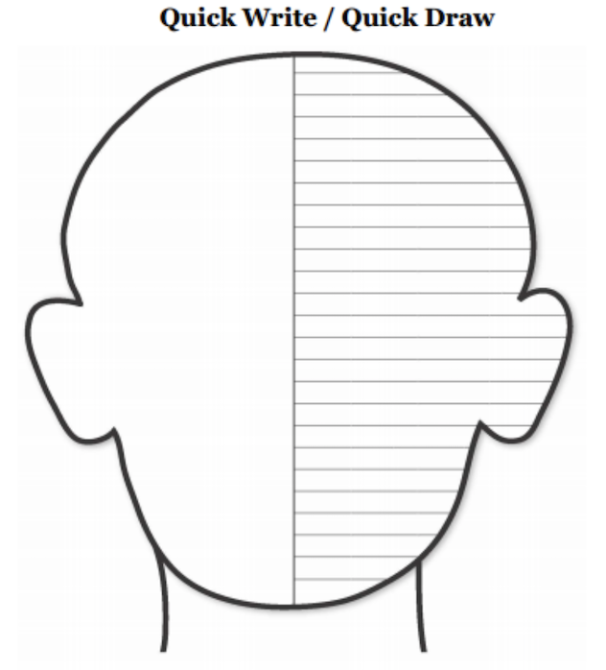
Draw a scenario from the skit you can relate to a past encounter you had with a bully. Then write about how you reacted or could have reacted differently.

Teacher Checklist
Student Name: __________
Total:___/6

- Identifies one (1) External characteristic of their chosen character
- Identifies one (1) internal characteristic of their chosen character
- Draws a scenario of either the skit or they’re real-life on the Quick Draw / Quit Write (QDQR) Exit Ticket
- Accurately gives an example of something in the skit.
- Accurately relates that example to their life

