GRADE: 4

Was “grit” the secret sauce that fueled the Industrial Revolution?

Student Name_____________________
Date______________________________

Part III: This part consists of a document-based question. On this part, you will be provided with one version of the test based on your readiness to handle critical thinking challenges.
Document Based Question

Directions: The task below is based on documents 1 through 6. The task is designed to test your ability to work with documents. Examine each document and answer all questions beneath the document. Use the answers to the questions to help write your essay.

Background: This question asks you to form an opinion based on the evidence in the documents that follow. Although you may have your own opinion, based your answer on proving your position with the documents. You can add outside information

Task: Use the information from the documents and your knowledge of social studies, write an essay in which you:
Use the information from the documents and your knowledge of social studies, write an essay in which you:

● Evaluate if you believe “grit” was the secret sauce that fueled the Industrial Revolution?
In your essay remember to
● Write an opinion essay, arguing whether people live a happier life in Mexico or America
● Include an introduction, a body, and a conclusion
● Use information from at least four documents in your answer
● Include historical facts, relevant details, and reason in developing your ideas
Document 1
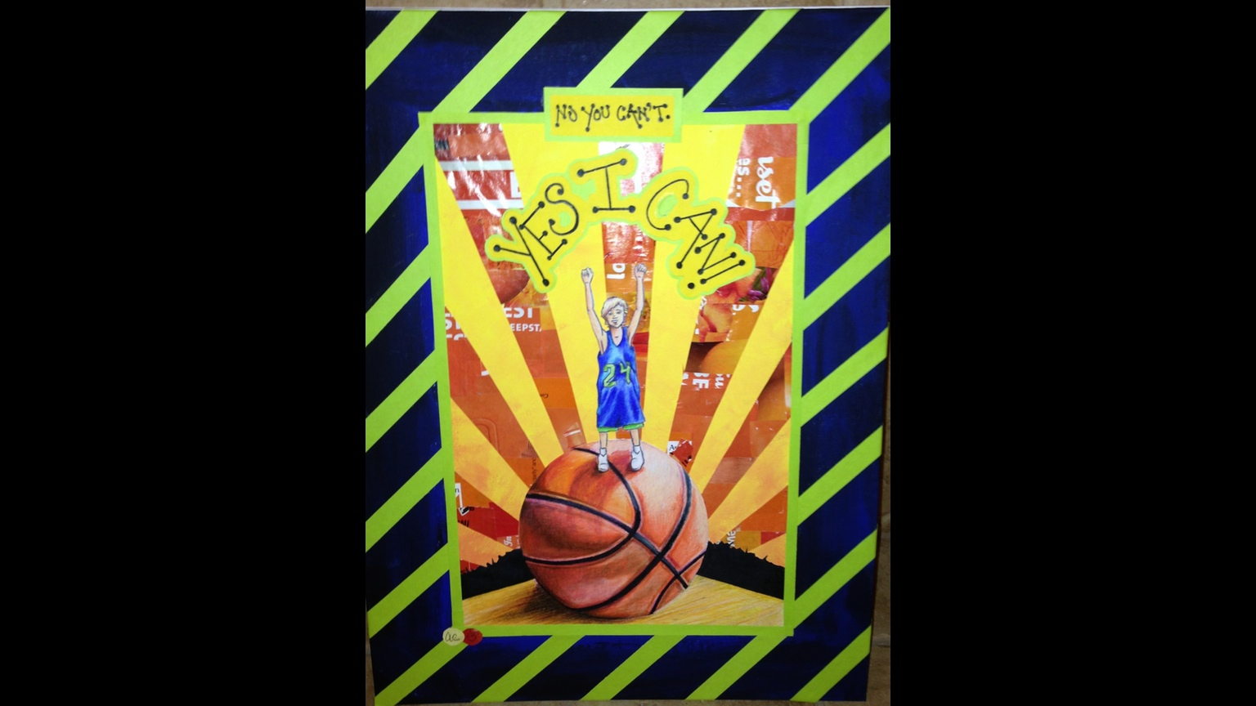
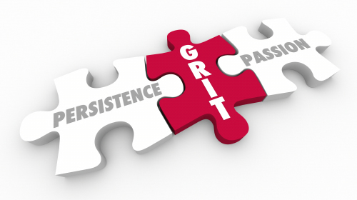
No you can’t, Yes I Can
Justin Allen
1. In No You Can’t, Yes I Can, what are the parts of grit that enable Justin to overcome his obstacles ?
A.____________________________________________________________________________________________________________________________________________________(2)
B._______________________________________[_______________________________________________________________________________________________________ [2]

2. Based on the unit and this DBQ, tell about one inventor or entrepreneur that had the same qulaities as Justin Allen.
._______________________________________[_______________________________________________________________________________________________________ [2]

Document 2
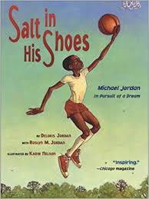

Salt in his Shoes
Delores Jordan

When Michael tells his father that the salt in his shoes did not make him grow, His father responds that height is not what makes one great. Instead, he tells Michael that the secret of greatness is something beyond physical gifts

Michael:

If I were taller, I would be a great player and I could help our team win…

Michael’d Father

But you are a great player and you have everything that it takes to win. Right in here. He tapped Michaels chest. Being taller might help to make you a better player, but not as much as practice, determination and giving your best will.

1. Based on the document above, what does Michael believe is the secret of greatnees?
_________________________________________________________________________________________________________________________________________ [2]

2. According the above document, what are three things does say lead to greatness?
____________________________________________________________________________________________________________________________________________________________________________________________________________________________________________________________________________________ [3]

Document 3a
One of several letters written by Milton Hershey to his Uncle pleading for financial assistance before he officially filed for bankruptcy in 1882.

Dear Uncle, Philadelphia, Jan 14, 1881
You [wrote to me that you were sorry to have] disappointed me…. but money matters are so tight with me that it is impossible to comply with your request for(a loan)
Your Respects,
Nephew M S Hershey
(Milton’s Uncle)

Document 3b
“I failed. It was a bad beginning… I suppose I never would have done anything if I hadn’t kept coming back.”
Milton Hershey
Source: Hershey Archives

- According to document 1a, why did Milton’s uncle turn down his request for money? [1] __________________________________________________________________
__________________________________________________________________

- Combining document 1a and 1b, what was the start of Milton Hershey’s business career like? [2]
________________________________________________________________________
______________________________________________________________________

- According to Hershey in document 1b, why did he succeed? [1]
________________________________________________________________________
_______________________________________________________________________

Document 4

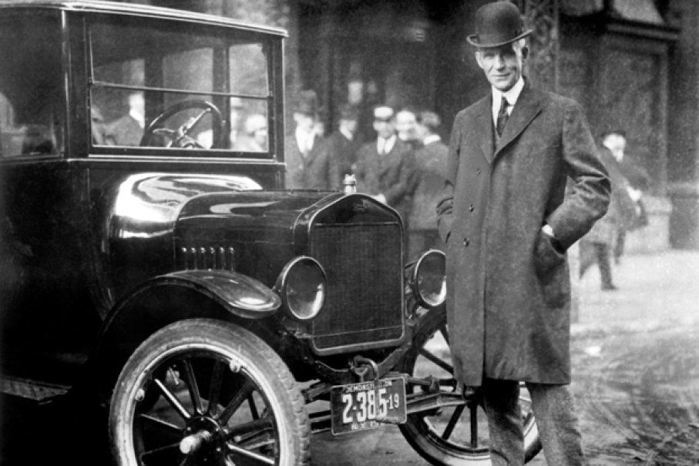
The first batch of the Model A’s were anything but flawless.(perfect). In fact, they had so many problems that the Ford Motor Company had to send mechanics to every corner of the country to fix cars. But when the mechanics came back, they came back with feedback; feedback that Ford immediately implemented in his assembly line. With the help of Couzens, they kept shipping, kept making mistakes and kept learning.
It would take 5 more years and countless failures before the Ford Motor Company came out with the world’s best automobile – the Model T. The Model T revolutionized the automobile industry and brought Ford to the forefront of that industry. Not only that, he helped establish Detroit as one of the biggest, wealthiest cities in America

Overcoming Failure: The Perseverance of Henry Ford
Morgan Ostrowski

Document 4b
“Whether you think you can, or think you can't- You're right”
- Henry Ford

- According to document 4a, why wasn’t the first batch of Model A’s successful? [2]
__________________________________________________________________
__________________________________________________________________

- According to the document 4a, how did Henry Ford react to the failures in the Model A? [2]
__________________________________________________________________
_______________________________________________________________
- What does Ford mean by the quote in document 4b? [2]
__________________________________________________________________
__________________________________________________________________
_______________________________________________________________

Document 5
John D. Rockefeller
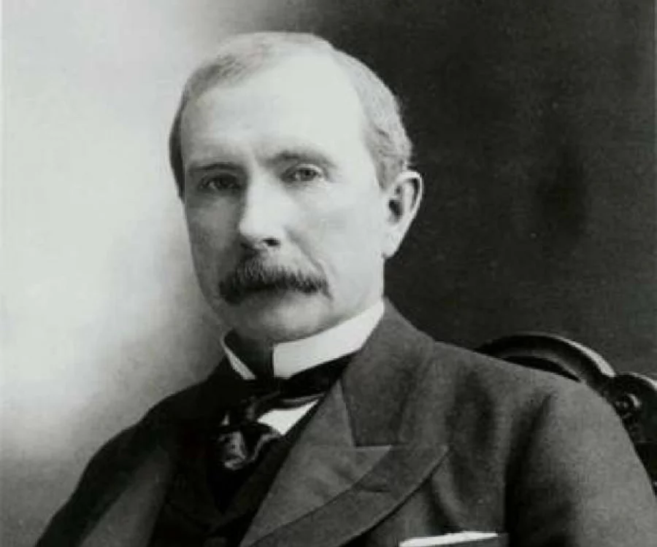
“I always tried to turn every disaster into an opportunity” - Rockefeller

“I do not think that there is any other quality so essential to success of any kind as the quality of perseverance. It overcomes almost everything, even nature.” - Rockefeller

Source: Titan: The Life of John D. Rockefeller by Ron Chernow

- What does Rockefeller say about perseverance in the documents above? [1] ________________________________________________________________________________________________________________________________________________
- What two phrases in the quotes above suggest that Rockefeller has grit? [2] _______________________________________________________________________________________________________________________________________________________________________________________________________________________

Document 6

Document 6a.
“Our virtues and our failings are inseparable, like force and matter. When they separate, man is no more.” – Nikola Tesla
Excerpt from the Department of Energy

Document 6b.
Tesla was not a savvy businessman and suffered financially, despite his achievements. He lost financial backing from Morgan, who felt he couldn’t profit from Tesla’s wireless electricity concept, and sold his assets to make up for dual foreclosures on Wardenclyffe. The property was later sold to a film processing company. In 1917, the U.S. government demolished Tesla’s partially completed tower because it worried German spies would use it to intercept communications during World War 1.

Despite these setbacks,Tesla went on to invent alternating current and the remote control.

Source: The life of Nikola Tesla 1993
- According to the quote in document 6a, what does Nikola Tesla suggest will happen if failure and virtue are separated? [2] ________________________________________________________________________________________________________________________________________________________________________________________________________________________

- a) According to document 6b, what were two financial setbacks Tesla faced? [2] ________________________________________________________________________________________________________________________________________________________________________________________________________________________
b) How was Tesla affected by these setbacks? [2] ________________________________________________________________________________________________________________________________________________________________________________________________________________________

Document 7a
“Our greatest weakness lies in giving up. The most certain way to succeed is always to try just one more time.” -Thomas Edison

Document 7b
“ In years gone by, one Edison, the “Wizard”, was a laughing stock, but he has turned the laugh until it is now being ripped out all over the earth through the medium of the phonograph”

Excerpt from Chronicle supplement 1901

- How does Edison feel about giving up according to document 7a? [2] ________________________________________________________________________________________________________________________________________________________________________________________________________________________
- Does document 7b demonstrate Edison does Edison have grit? [1] _______________________________________________________________________________________________________________________________________________________________________________________________________________________

Task: Use the information from the documents:

Directions: The task below is based on documents 1 through 5. The task is designed to test your ability to work with documents. Examine each document and answer all questions beneath the document. Use the answers to the questions to help write your essay.

Background: This question asks you to form an opinion based on the evidence in the documents that follow. Although you may have your own opinion, based your answer on proving your position with the documents. You can add outside information

Task: Use the information from the documents and your knowledge of social studies, write an essay in which you:
Use the information from the documents and your knowledge of social studies, write an essay in which you:

● Evaluate Whether You Believe that Grit was the Secret Sauce that Fueled the Industrial Revolution

In your essay remember to
● Write an opinion essay, arguing whether where you live determines your happiness
● Include an introduction, a body, and a conclusion
● Use information from at least three documents in your answer
● Include historical facts, relevant details, and reason in developing your ideas

DBQ Scoring Rubric
(From the Revised Generic Scoring Rubric for Regents Examinations.)

Score of 5 | *Thoroughly develops all aspects of the task evenly & in depth | *Is more analytical than descriptive (applies, analyzes, evaluates, & creates information) | *Incorporates relevant information from at least the requested number of documents | *Incorporates substantial relevant outside information | *Richly supports the theme with many relevant facts, examples, & details | *Demonstrates a logical & clear plan of organization; includes and introduction & conclusion that are beyond a restatement of the theme
Score of 4 | *Develops all aspects of the task but may do so somewhat unevenly | *Is both descriptive & analytical (applies, analyzes, evaluates, and/or creates information) | *Incorporates relevant information for at least the requested number of documents | *Incorporates relevant outside information | *Supports the theme with relevant facts, examples, & details | *Demonstrates a satisfactory plan of organization; includes an introduction & a conclusion that are beyond a restatement of the theme
Score of 3 | *Develops all aspects of the task with little depth or develops most aspects of the task in some depth | *Is more descriptive than analytical (applies, may analyze and/or evaluate information) | *Incorporates relevant information from some documents | *Incorporates limited relevant outside information | *Includes some relevant facts, examples, & details; may include some minor inaccuracies | *Demonstrates a satisfactory plan of organization; includes an introduction & a conclusion that may be a restatement of the theme
Score of 2 | *Minimally develops all aspects of the task or develops some aspects of the task in depth | *Is primarily descriptive; may include faulty, weak, or isolated application or analysis | *Incorporates limited relevant information from the documents or consists primarily of relevant information copied from the documents | *Presents little or no relevant outside information | *Includes few relevant facts, examples, & details; may include some inaccuracies | *Demonstrates a general plan of organization; may lack focus; may contain digressions; may not clearly identify which aspect of the task is being addressed; may lack an introduction an/or an conclusion
Score of 1 | *Minimally develops some aspects of the task | *Is descriptive; may lack understanding, application, or analysis | *Makes vague, unclear references to the documents or consists primarily of relevant & irrelevant information copied from the documents | *Presents no relevant outside information | *Includes few relevant facts, examples, or details; may include inaccuracies | *May demonstrate a weakness in organization; may lack focus; may contain digressions; may not clearly identify which aspect of the task is being addressed; may lack an introduction and/or a conclusion
Score of 0 | *Fails to develop the task or may only refer to the theme in a general way; OR includes no relevant facts, examples or details; OR includes only the historical context and/or task as copied from the test booklet; OR includes only entire documents copied from the test booklet; OR is illegible: OR is a blank paper

